http://www.nytimes.com/2016/03/25/sports/football/nfl-concussion-research-tobacco.html?smid=tw-nytimes&smtyp=cur&mtrref=t.co&gwh=5174A46170F38F2B00C4DCDA555BCF07&gwt=pay&_r=2

PRO FOOTBALL

N.F.L.’s Flawed Concussion Research and Ties to Tobacco Industry
By ALAN SCHWARZ, WALT BOGDANICH and JACQUELINE WILLIAMSMARCH 24, 2016
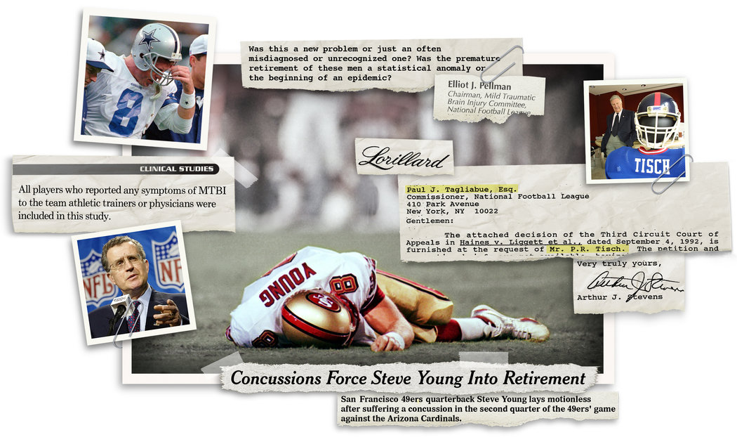
CreditIllustration by Sam Manchester/The NYT; Photographs by AP and The NYT
The National Football League was on the clock.
With several of its marquee players retiring early after a cascade of frightening concussions, the league formed a committee in 1994 that would ultimately issue a succession of research papers playing down the danger of head injuries. Amid criticism of the committee’s work, physicians brought in later to continue the research said the papers had relied on faulty analysis.
Now, an investigation by The New York Times has found that the N.F.L.’s concussion research was far more flawed than previously known.
For the last 13 years, the N.F.L. has stood by the research, which, the papers stated, was based on a full accounting of all concussions diagnosed by team physicians from 1996 through 2001. But confidential data obtained by The Times shows that more than 100 diagnosed concussions were omitted from the studies — including some severe injuries to stars like quarterbacks Steve Young and Troy Aikman. The committee then calculated the rates of concussions using the incomplete data, making them appear less frequent than they actually were.
After The Times asked the league about the missing diagnosed cases — more than 10 percent of the total — officials acknowledged that “the clubs were not required to submit their data and not every club did.” That should have been made clearer, the league said in a statement, adding that the missing cases were not part of an attempt “to alter or suppress the rate of concussions.”
One member of the concussion committee, Dr. Joseph Waeckerle, said he was unaware of the omissions. But he added: “If somebody made a human error or somebody assumed the data was absolutely correct and didn’t question it, well, we screwed up. If we found it wasn’t accurate and still used it, that’s not a screw-up; that’s a lie.”
These discoveries raise new questions about the validity of the committee’s findings, published in 13 peer-reviewed articles and held up by the league as scientific evidence that brain injuries did not cause long-term harm to its players. It is also unclear why the omissions went unchallenged by league officials, by the epidemiologist whose job it was to ensure accurate data collection and by the editor of the medical journal that published the studies.
In 2013, the N.F.L. agreed to a $765 million settlement of a lawsuit in which retired players accused league officials of covering up the risks of concussions. Some players have appealed the settlement, asking for an examination of the committee’s concussion research.
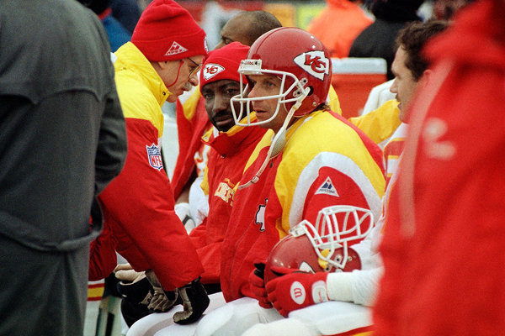
Dr. Joseph Waeckerle, speaking to quarterback Joe Montana in 1994, was the Chiefs’ team physician and a member of the N.F.L.’s concussion committee. CreditAssociated Press
Some retired players have likened the N.F.L.’s handling of its health crisis to that of the tobacco industry, which was notorious for using questionable science to play down the dangers of cigarettes.
Concussions can hardly be equated with smoking, which kills 1,300 people a day in the United States, and The Times has found no direct evidence that the league took its strategy from Big Tobacco. But records show a long relationship between two businesses with little in common beyond the health risks associated with their products.
In a letter to The Times, a lawyer for the league said, “The N.F.L. is not the tobacco industry; it had no connection to the tobacco industry,” which he called “perhaps the most odious industry in American history.”
Still, the records show that the two businesses shared lobbyists, lawyers and consultants. Personal correspondence underscored their friendships, including dinner invitations and a request for lobbying advice.
In 1997, to provide legal oversight for the committee, the league assigned Dorothy C. Mitchell, a young lawyer who had earlier defended the Tobacco Institute, the industry trade group. She had earned the institute’s “highest praise” for her work.
A co-owner of the Giants, Preston R. Tisch, also partly owned a leading cigarette company, Lorillard, and was a board member of both the Tobacco Institute and the Council for Tobacco Research, two entities that played a central role in misusing science to hide the risks of cigarettes.
The N.F.L.’s concussion committee began publishing its findings in 2003 in the medical journal Neurosurgery. Although the database used in the studies contained numerical codes for teams and players, The Times decoded it by cross-referencing team schedules and public injury reports.
The N.F.L.’s concussion studies have faced questions since they were published, but even the league’s harshest critics have never suggested, and no evidence has ever arisen, that the underlying data set could be so faulty.
“One of the rules of science is that you need to have impeccable data collection procedures,” said Bill Barr, a neuropsychologist who once worked for the Jets and who has in the past criticized the committee’s work.
By excluding so many concussions, Mr. Barr said, “You’re not doing science here; you are putting forth some idea that you already have.”

The Work Begins
In an introduction to the first of the concussion committee’s papers, the league’s commissioner at the time, Paul Tagliabue, acknowledged the need for “independent scientific research” to better understand the risks of concussions.
“As we looked more deeply into the specific area of concussions, we realized that there were many more questions than answers,” Mr. Tagliabue wrote.
The committee’s chairman, Dr. Elliot Pellman, the team physician for the Jets, emphasized that his group aimed to produce research that was “independent” and “meticulous.”
In fact, most of the dozen committee members were associated with N.F.L. teams, as a physician, neurosurgeon or athletic trainer, which meant they made decisions about player care and then studied whether those decisions were proper. Still, the researchers stated unambiguously — in each of their first seven peer-reviewed papers — that their financial or business relationships had not compromised their work.
The committee said it analyzed all concussions diagnosed by team medical staffs from 1996 through 2001 — 887 in all. Concussions were recorded by position, type of play, time missed, even the brand of helmet.
The committee’s statements emphasized the completeness of the data.
“It was understood that any player with a recognized symptom of head injury, no matter how minor, should be included in the study,” one paper said.
And in confidential peer-review documents, the committee wrote that “all N.F.L. teams participated” and that “all players were therefore part of this study.”
Those statements are contradicted by the database.
The Times found that most teams failed to report all of their players’ concussions. Over all, at least 10 percent of head injuries diagnosed by team doctors were missing from the study, including two sustained by Jets receiver Wayne Chrebet, who retired several years later after more concussions. Dr. Pellman, the Jets’ physician, led the research and was the lead author on every paper.

Prominent Holes in N.F.L. Study
In the mid-1990s, the National Football League formed a concussion committee that ultimately determined that head trauma posed no significant danger. But the data it collected from teams was inconsistent and contained glaring omissions — some involving the game’s star players.

The 49ers have no concussions listed from 1997 through 2000. However, numerous media reports and the N.F.L.’s own injury reports indicate quarterback Steve Young had at least two. The one at left occurred against Arizona in 1999. Young did not play again.
Young listed on midweek N.F.L. injury reports
Sept. 3, 1997
Sept. 29, 1999
Concussion
Concussion
LENNY IGNELZI/ASSOCIATED PRESS
The Cowboys do not have a single concussion in the database, which covers six seasons. But according to media reports and the N.F.L.’s injury reports, quarterback Troy Aikman sustained four during that time, including one against the Eagles in 1997, left.
Aikman listed on midweek N.F.L. injury reports
Oct. 29, 1997
Nov. 10, 1999
Sept. 6, 2000
Dec. 13, 2000

Concussion
Head*
Concussion
Concussion

GEORGE WIDMAN/ASSOCIATED PRESS
*Sometimes injury reports refer to concussions as head injuries. News media outlets at the time reported that Cowboys officials had said Aikman sustained a "mild concussion."
The New York Times; By Andrew W. Lehren and Alan Schwarz
According to the research papers, team physicians were to fill out forms specially designed for the studies to submit information about concussions — a system that went well beyond the league’s standard injury-reporting protocols. In one paper, the committee wrote, “The Commissioner of the N.F.L. mandated all team physicians to complete and return forms whenever they examined a player with a head injury.”
But after The Times described how it had identified missing concussions, the N.F.L. said this week that the studies, in fact, “never purported” to include all concussions.
Teams were “not mandated” to participate, the league said, only “strongly encouraged.” And some teams, a spokesman said, “did not take the additional steps of supplying the initial and/or follow-up forms.” He did not explain why some teams had not included all concussions identified by medical personnel.
The league explained, as did the papers, that some concussions went undiagnosed in the first place because players are known to occasionally hide their symptoms of concussion from team doctors; that symptoms of concussion can be so brief that no one notices; and that doctors might have used different criteria to make concussion diagnoses.
But the vast majority of omitted concussions identified by The Times were included in the N.F.L.’s public injury reports, meaning that medical staffs had made the diagnoses and reported them to the league. Some of the omitted concussions were reported by the teams to the news media after a game but do not appear on the injury reports, presumably because the player’s status for the next game was not in doubt.

As N.F.L. commissioner, Paul Tagliabue wrote in an introduction to the concussion committee’s first paper that “independent scientific research” was needed. CreditEd Andrieski/Associated Press
The database does not include any concussions involving the Dallas Cowboys for all six seasons, including four to Mr. Aikman that were listed on the N.F.L.’s official midweek injury reports or were widely reported in the news media. He and many other players were therefore not included when the committee analyzed the frequency and lasting effects of multiple concussions.
Several other teams have no concussions listed for years at a time. Yet the committee’s calculations did include hundreds of those teams’ games played during that period, which produced a lower overall concussion rate.
A Cowboys spokesman, Rich Dalrymple, said the team had participated, but he declined to say how many cases were reported and which players were involved. He said he did not know why the Cowboys’ data did not appear in the studies. A San Francisco 49ers spokesman did not return messages seeking comment about Mr. Young.
Dr. Robert Cantu, one of the peer reviewers who at the time criticized the committee’s analyses, said, “It should be an unmistakable red flag that a team does not report any concussions over multiple years.”
Some injuries were more severe than what was reflected in the official tally. According to committee records, St. Louis Rams quarterback Kurt Warner sustained a concussion on Dec. 24, 2000, that healed after two days. But Mr. Warner’s symptoms continued, and four weeks later he was ruled out of the Pro Bowl with what a league official described as lingering symptoms of that head injury.
The N.F.L. declined to make Dr. Pellman available for an interview. The study’s epidemiologist, John Powell, who no longer works on behalf of the league, did not respond to interview requests. Michael L. J. Apuzzo, editor of Neurosurgery when the papers were published, did not respond to interview requests.

The N.F.L.’s Tragic C.T.E. Roll Call
Chronic traumatic encephalopathy, a degenerative brain disease, has been found in dozens of former N.F.L. players. Here are some of the most notable cases, along with New York Times coverage.
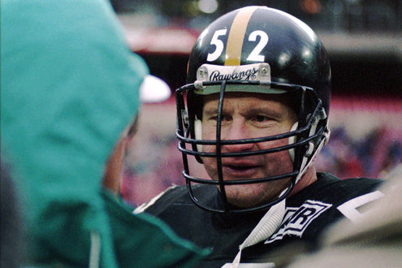

The committee and the N.F.L. have long claimed that the papers were vetted through a rigorous, confidential peer-review process before publication, which legitimized their methods and conclusions. But more than a dozen pages of anonymous back-and-forth between reviewers and the committee show some reviewers almost desperate to stop the papers’ publication while the authors brushed aside criticism.
One reviewer wrote, “Many of the management of concussion suggestions are inappropriate and not founded on facts.” Another said the committee’s assertion that the league was handling concussions too cautiously was not proved and was therefore “potentially dangerous.”
An author of the N.F.L. studies responded, “If the truth is dangerous, then I suppose our results are dangerous.”

Overlapping Interests
In 1992, amid rising concerns about concussions, Mr. Tisch — the Giants and Lorillard part owner — asked the cigarette company’s general counsel, Arthur J. Stevens, to contact the N.F.L. commissioner at the time, Mr. Tagliabue, about certain legal issues.
Mr. Stevens was not just any tobacco lawyer; he was a member of the industry’s secretive Committee of Counsel, which helped direct tobacco research projects. In a letter obtained by The Times, Mr. Stevens referred Mr. Tagliabue to two court cases alleging that the tobacco and asbestos industries had covered up the health risks of their products.
In one case, the family of a dead smoker sought internal documents that the tobacco industry had withheld on the grounds of lawyer-client privilege — which does not apply if invoked to cover up a crime. The judge in the case reacted angrily after reading those internal records.
“The documents speak for themselves in a voice filled with disdain for the consuming public and its health,” the judge, H. Lee Sarokin of Federal District Court in New Jersey, wrote earlier in 1992. Tobacco lawyers succeeded in having Judge Sarokin removed from the case.
Why an influential tobacco lawyer would recommend legal cases to the N.F.L. is not known, because neither Mr. Stevens nor Mr. Tagliabue would agree to be interviewed. Mr. Tisch died in 2005.
Joe Lockhart, a league spokesman, said that the cases involved potential bias of judges and that there was no evidence that the letter “was taken seriously.”
Even so, records show that, in the legal arena, the league and the tobacco industry sometimes intersected.
Before joining the N.F.L., Ms. Mitchell, a young Harvard Law School graduate, had been one of five lawyers at Covington & Burling who had provided either lobbying help or legal representation to both the N.F.L. and the tobacco industry, sometimes in the same year. Mr. Tagliabue had been a partner at the firm before becoming the N.F.L.’s commissioner.
In 1992, Ms. Mitchell defended the Tobacco Institute against a smoker’s lawsuit. She also worked on behalf of the institute in a landmark secondhand smoke case, as well as for other nontobacco clients. Ms. Mitchell said she was not responsible for legal strategy in the tobacco cases.
At the N.F.L., said Brian McCarthy, a league spokesman, Ms. Mitchell’s work for the concussion committee was administrative. “She did not have any responsibility or any role in directing the research,” he said.
Dr. Waeckerle, the concussion committee member, offered a different view.
He said Ms. Mitchell asked committee members: “How can this affect us? How can this be studied? How should we view it? Is this a legitimate concern, or is this part of somebody’s zeal, and do we need to be concerned?”
Photo
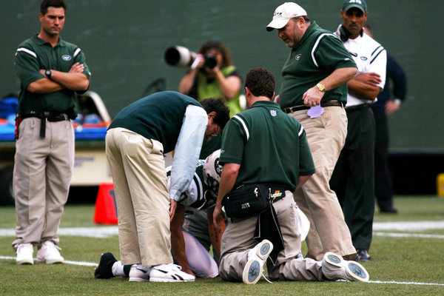
Wayne Chrebet being attended to in 2003 by the Jets’ team doctor, Elliot Pellman, right, who led the N.F.L.’s research on concussions. Among the head injuries missing from the N.F.L.’s studies were two sustained by Chrebet. CreditOzier Muhammad/The New York Times
Dr. Waeckerle praised her for bringing a nonmedical voice that made members consider the risks, benefits and “what are the intended and nonintended consequences of whatever we were discussing.” He said, for example, that she wanted to ensure that the committee’s work applied only to the N.F.L., not to college or youth football.
Ms. Mitchell said in an interview that she left the N.F.L. after six years for personal reasons, unrelated to her work, and that she did not recall much about the committee’s work.
“I don’t think I saw any reports,” she said. “It was in the early stages.”
Ms. Mitchell added that, as the league’s assistant secretary, she had broad responsibilities beyond health and safety issues.
Her contributions to the concussion committee won her thanks in five research papers — three by the N.F.L. and two by a Canadian company that did contract work for the N.F.L. The committee wrote that she worked “tirelessly to initiate” its research and that “her efforts paved the way for successful completion of the research.”
On at least two occasions in the 1970s and 1980s, the N.F.L. hired a company whose client list included the Tobacco Institute to study player injuries. The league also hired a company — for a matter unrelated to player safety — that had performed a study for the tobacco industry that played down the danger of secondhand smoke.
The N.F.L.’s ties to tobacco are reflected in other ways. When Congress was considering legislation that dealt with when a team owner could relocate a franchise, Joe Browne, a league official sought lobbying advice from a representative of the Tobacco Institute.
“I would like to take the opportunity to sit down and discuss this bill with you further,” Mr. Browne said in a 1982 letter to the institute’s president, Sam Chilcote.
Neil Austrian, a former N.F.L. president, had previously run an advertising agency that under his leadership reversed its ban on taking tobacco clients. He called Philip Morris “an honorable company that sets high standards.” It was during his tenure at the N.F.L. that the concussion committee was created.
Years later, when the committee’s work drew criticism during the peer review process, its members pushed back.
“We are aware the findings from the N.F.L. confront some popular opinions,” they wrote, “but believe this study stands on its merits based on the physician evaluation of injury and quality assurance of the data.”

Neurologic Rehabilitation Institute at Brookhaven Hospital
201 S. Garnett Rd.
Tulsa, OK 74128
http://www.traumaticbraininjury.net/the-new-york-times-finds-massive-flaws-in-nfls-concussion-studies/

The New York Times Finds Massive Flaws In NFL’s Concussion Studies
Paul Stone | MARCH 24, 2016
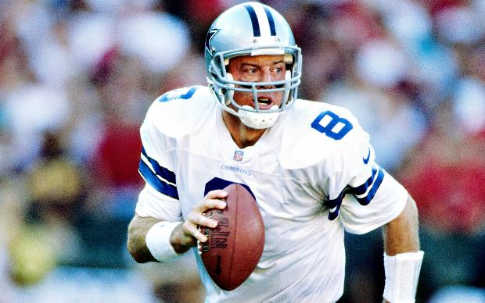
Source: USA TODAY Sports
Since 1994, the NFL’s concussion committee has released research downplaying the effects and dangers of concussions in professional football. The group has received strong criticism for its work, but the league has consistently stood by this research and regularly cited it when discussing head trauma in the NFL.
However, The New York Times has uncovered evidence that the studies were much more flawed than anyone imagined.
According to the report, the data used for the research published by the NFL’s concussion group excluded over 100 diagnosed concussions. This isn’t just an issue of misdiagnosis, either. The research excludes serious brain injuries experienced by famous players like Steve Young and Troy Aikman, despite these injuries appearing in weekly injury reports from the league at the time. By using this incomplete data, the committee was able to not only make concussions appear less frequent than they really were – they were able to downplay the severity of these concussions as well.
When questioned by The Times about the missing injuries in the research, officials from the NFL conceded that “the clubs were not required to submit their data and not every club did.” The league also said it should have been made clearer, but denied that the missing cases were part of an effort to “alter or suppress the rate of concussions.”
The league also says it never purported to include all concussions in their research, but the actual studies as published tell a different story.
One paper says, “It was understood that any player with a recognized symptom of head injury, no matter how minor, should be included in the study.” Another states, “all NFL teams participated” and “all players were therefore part of this study.”
Public statements from the committee also emphasized the completeness and thoroughness of the data.
According to the data obtained by The Times, approximately 10 percent or more of head injuries diagnosed by team doctors were missing from the study, including two sustained by Jets receiver Wayne Chrebet, who was later forced to retire due to brain injuries. The Jets’ team physician, Dr. Pellman, led the research and was the lead author on every paper released by the committee.
One explanation given by the league for why players may not have been included in the data is that players are known to often hide concussion symptoms from team doctors or that some brain injuries can be so short-lasting they go unnoticed. But, the majority of the concussions omitted in the research did not go unnoticed at the time.
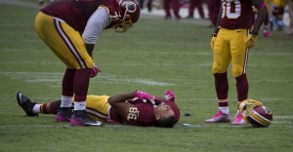
Source: Keith Allison / Flickr
The bulk of the missing concussions were included in the NFL’s public injury reports, which means the injuries were diagnosed and reported to the league. Others were reported to media after games but did not appear on injury reports. This is likely because the player’s recovered quickly and were cleared to compete in the next game.
Several teams had staggeringly incomplete concussion data. The database does not include any information regarding concussions involving the Dallas Cowboys for all six seasons the league collected data. Other teams listed no concussions for years at a time. Despite this, the committee included games played by these teams when calculating overall concussion rate per time on the field, which produces a significantly lower rate.
Interestingly, a Cowboys spokesman told The Times that the team had participated and he was not sure why data from the team did not appear in the studies.
Injuries were also mischaracterized in the database to appear less severe. According to committee records, St. Louis Rams quarterback Kurt Warner experienced a concussion on Dec. 24, 2000. This concussion supposedly healed in two days in their report. However, Warner’s concussion symptoms lasted more than four weeks, preventing him from playing in the Pro Bowl that year.
Despite this evidence, the NFL says it still stands by its findings and released a statement saying “Contact sports will never be concussion-free, but we are dedicated to caring for our players, not just throughout long careers but over the course of long lives.”

These new revelations add to the growing body of evidence suggesting the NFL knowingly misrepresented and downplayed the severe risks of brain injuries in football well after they were known. Nonetheless, the new information discredits the NFL’s past research and casts further doubt on their recent research activities.
As concussion committee member Dr. Joseph Waeckerle told The Times: “If somebody made a human error or somebody assumed the data was absolutely correct and didn’t question it, well, we screwed up. If we found it wasn’t accurate and still used it, that’s not a screw-up; that’s a lie.”
concussion, concussion crisis, Concussion in the NFL, football and concussions, football and TBI,New York Times, NFL and TBI NFL concussion crisis, NFL concussion, NFL concussion committee,traumatic brain injury and football

